Aquatic Forget-Me-Not Control on Lake Owen
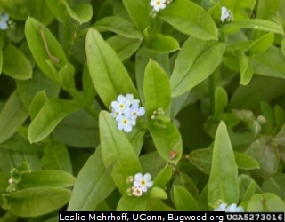
Aquatic Forget-Me-Not is one of three invasive plants present in Lake Owen. The other aquatic species are yellow iris and phragmites grass, both shoreline plants. Although Aquatic Forget-Me-Not is a plant with pretty, little cornflower blue flowers, it is a concern, and we are working to remove it from our shorelines. It is shallow-rooted and easy to pull. However, abundant seeds allow the plant to spread readily.
According to the Wisconsin Department of Natural Resources: “Aquatic forget-me-not can quickly crowd out native plant species and can form large monocultures, especially in situations where it is in or near a stream. This, in turn, affects community composition by reducing the number of native herbs.” The plant can also ready spread and take over in wetlands and shallow water in lakes.
Aquatic Forget-Me-Not is widespread on Lake Owen shores as shown in the map. Our Lake Scientist, Steve Schieffer, identified plant locations this past summer. The LOA then notified owners and requested that they pull the plant to reduce its growth. A follow-up survey in 2025 will indicate how successful this effort was. We expect that multiple years of pulling will be necessary. We appreciate owners who removed Aquatic Forget-Me-Not on their properties.
