**Lake Owen Association Lake Management Plan Summary**

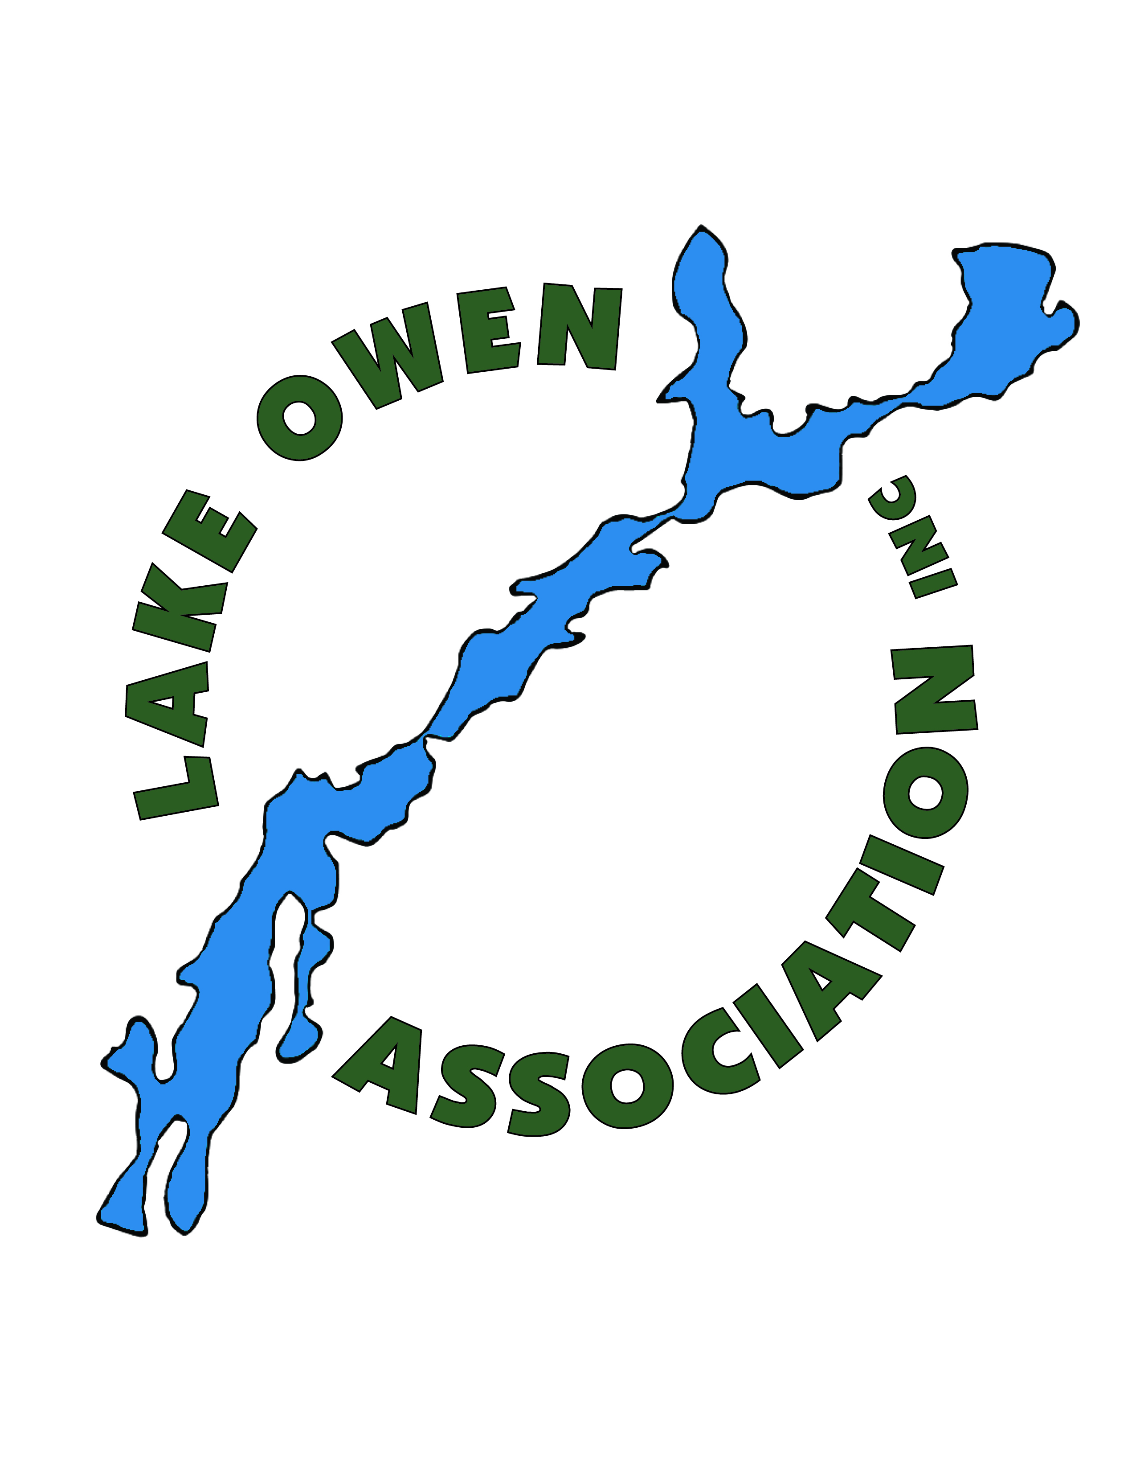

## Our Vision for Lake Owen

*A pristine refuge sustained by an engaged community*

## Mission of the Lake Owen Association

*Preserve and Protect Lake Owen*

## Lake Owen Management Plan Goals

1. **Prevent the introduction and establishment of invasive species.**
2. **Preserve water quality.**
3. **Protect and restore in-lake, near shore, and shoreland habitat.**
4. **Inspire active stakeholder involvement.**
5. **Retain best in class lake management.**
6. **Establish sustainable financial resources.**

## How We Will Reach These Goals

*The Lake Owen Association (LOA) Board is working together with professional lake managers and agency partners to preserve and protect Lake Owen and carry out the recommendations of our Lake Management Plan. The Lake Owen Lake Management Plan provides additional information about Lake Owen water quality, habitat, threats, public input, and much more. Selected activities are highlighted in this executive summary.* ***The full plan is available on the Lake Owen website*** [***https://lakeowen.org/***](https://lakeowen.org/)***.***

*We welcome your support and involvement as we work to maintain Lake Owen as our pristine refuge. Specific objectives, evaluation measures, and more detailed action descriptions are included in the Lake Owen Lake Management Plan.*

1. ***Prevent the introduction and establishment of invasive species.***
   * Continue Clean Boats, Clean Waters inspections at the public landings.
   * Provide best available boat and equipment decontamination.
   * Be prepared with aquatic invasive species rapid response plan.
   * Monitor the entire lake for aquatic invasive species monthly during the summer.
   * Control invasive species yellow iris, aquatic forget-me-not, and phragmities.

1. ***Preserve water quality.***
   * Continue water quality assessment and share results.
   * Develop a program to recognize efforts of Lake Owen property owners through on-site evaluation and shoreline markers.

* Establish a program to encourage owners to replace failing septic systems.
* Develop and distribute outreach materials re: best practices to protect lake water quality.

1. ***Protect and restore in-lake, near shore, and shoreland habitat.***
   * Identify important Lake Owen fish and wildlife habitat and share information with owners and visitors.

1. ***Inspire active stakeholder involvement.***

* Develop an outreach/marketing calendar to increase effectiveness of LOA outreach.
* Maintain on-line member directory to encourage interaction.
* Increase membership and member participation at annual meetings and other events.
* Continue popular pontoon classrooms, guided hikes, and other LOA activities.
* Host gatherings for the next generation of Lake Owen owners to get acquainted.
* Provide annual reports and hold meetings with key stakeholders.
* Monitor lake-related public policy and regulations and inform stakeholders.

1. ***Retain best in class lake management.***
   * Complete annual review/self-evaluation for lake managers.
   * Identify model programs and organizations to learn from their activities.
   * Seek outside expertise and study results when needs are identified.
2. ***Maintain a sustainable organization with adequate financial resources.***
   * Raise $2.5 million for endowment fund to support LOA activities into the future.
   * Maintain eligibility and apply for grant dollars.
     + Update strategic implementation plan tables annually.

## Lake Owen Association Accomplishments 2019 -2024

**Aquatic Invasive Species (AIS) Prevention**

* Completed whole lake aquatic plant survey.
* Completed monthly AIS meander surveys (June, July, and August each year).
* Staff a boater education and inspection and decontamination station using a hot water, high pressure washer at the US Forest Service North Outlet Landing (approved late summer 2020). Provide boater education and staff a decontamination station using a mild bleach solution at the USFS Two Lakes Campground (approved late summer 2021 and installed in 2022) and Otter Bay Resort (beginning in 2024).
* Encouraged Bayfield County to amend their aquatic invasive species ordinance to require decontamination when available at a lake public access. Bayfield County acknowledged LOA influence at a state conference. Ordinance was amended July 2020.
* Completed aquatic invasive species rapid response plan.
* Installed sampling devices to monitor for potential zebra mussel establishment.
* Monitor traffic flow at landings using TrafX devices to target decontamination staffing.
* Encouraged the Towns of Drummond and Cable to adopt a home lake rule that requires wake boats traveling from other lakes to be professionally decontaminated before entering Lake Owen.

**Aquatic Invasive Species Control**

* Inventoried the lake for yellow iris and other aquatic invasive species each June. Control measures (chemical and hand-removal) were completed in 2019, 2021, 2022, 2023 and 2024.
* Identified parcels with invasive aquatic forget-me-not and encouraged owners to hand pull on their parcels.

**Water Quality**

* Completed water quality study and reports: full report and executive summary available on the website [*https://lakeowen.org/*](https://lakeowen.org/). With this baseline, fewer water flow and quality measurements are now taken to monitor ongoing conditions.
* Identified and mapped important Lake Owen fish and wildlife habitat areas (report December 2022).
* Provided water quality landscaping site evaluations for 13 Lake Owen property owners.
* Developed preliminary design documents for Lake Owen Villas to reduce runoff to the lake. The LOVA will implement recommendations on their own schedule and budget. Presented suggestions for Virginia Beach Condo Association.
* Developed groundwater model for Lake Owen (March 2022 report).
* Installed thermistor string long term temperature profile monitoring (2022, 2023 and 2024).

**Outreach**

* Held two focus groups with Lake Owen owners to gain insight regarding lake management and the work of Lake Owen Association (August 2022). The focus group results guided the development of a Lake Owen Property Owners Survey administered in November 2022. Results from both now inform the work of the LOA.
* Developed a new LOA brochure for distribution at landings which included an attractive lake map. Topics included prevention of aquatic invasive species, no-wake requirements, and important aquatic plant habitat areas.
* Improved and updated information on the LOA website.
* Used email campaigns to distribute relevant information to property owners.

**Organization**

* Completed a successful Wisconsin Department of Natural Resources Lake Protection Grant project from 2018 to 2022.
* Applied for and was awarded new DNR grant funding to support LOA activities beginning in 2023 including:
  + Aquatic invasive species decontamination,
  + Clean Boats, Clean Waters boater education to prevent invasive species introduction at the landings,
  + Water quality and habitat assessments leading to an updated comprehensive lake management plan (3-year project).
* LOA Board held regular meetings to guide and support these activities.
* Established on-line directory (2024)

**Member Activities**

Expanded educational and social events for LOA members include:

* Next generation events
* Guided hikes
* Water quality pontoon tours
* Charity golf tournament
* 4th of July boat parade
* Spring and Fall “Raft-ups”
* Annual meeting and picnic